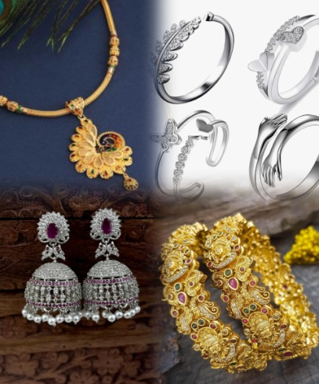

CRM APLLICATION FOR

JEWEL MANAGEMENT

DEVELOPMENT

College Name : Cherran college for women

College Code :bru5g1

TEAM ID : NM2025TMID28621

TEAM MEMBERS: 4

Team Leader Name : Dharshini Priya.R

Email : priyaraji1912@gmail.com

Team Member1 : Haseena Banu.M

Email : haseenahasee146@gmail.com

Team Member : Keerthana.K

Email : keerthanakaruppiaya@gmail.com

Team Member : Kiruba.A

Email : [sathyakiruba23@gmail.com](mailto:sathyakiruba23@gmail.com)

INTRODUCTION

Project Overview :

The Jewelry CRM is a custom-built system designed to support jewelry

businesses in managing customers, orders, pricing, billing, and items within a

centralized platform. By using custom objects and automation flows, the CRM

reduces manual work, ensures accurate record-keeping, and improves customer

communication through automated email alerts.

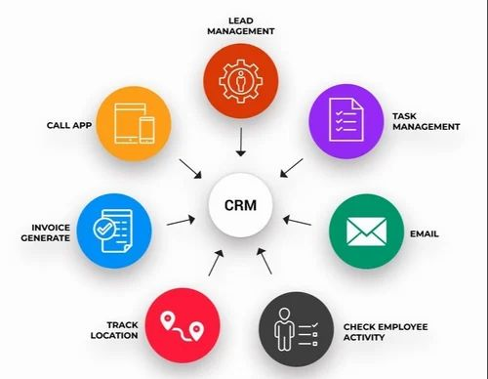

Purpose :

The **purpose of a CRM (Customer Relationship Management) application for**

**jewelry management** is to help jewelry businesses efficiently manage

customers, sales, inventory, and communication while improving overall

business performance.

**DEVELOPMENT PHASE**

* Creating Developer Account:

By using this URL - <https://www.salesforce.com/form/developer-signup/?d=pb>

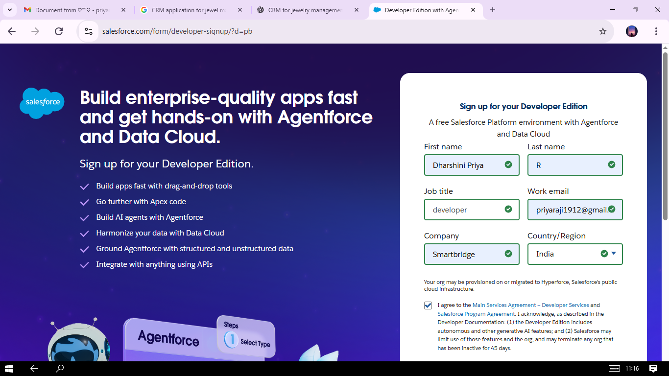

* Created objects : jewel customer,item,billings,customer order,price.

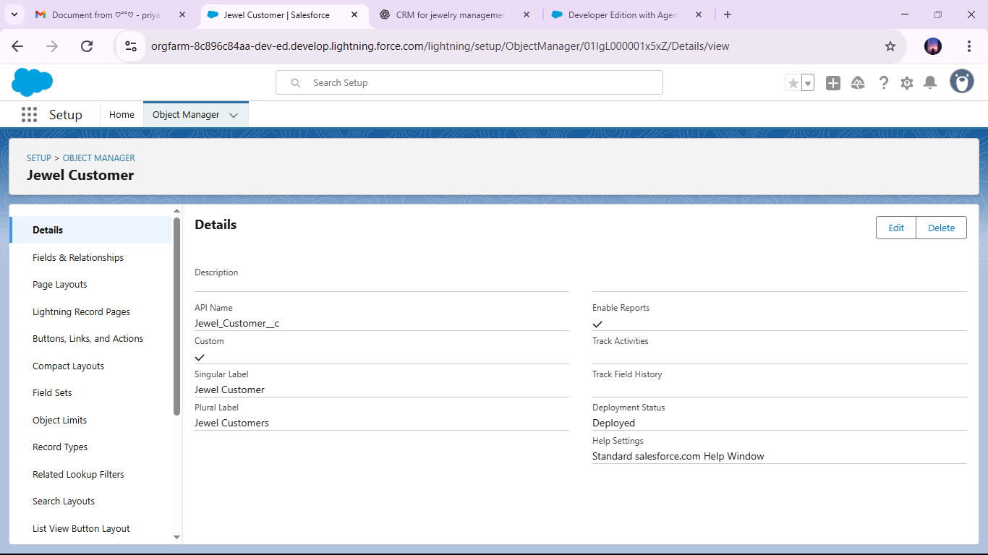

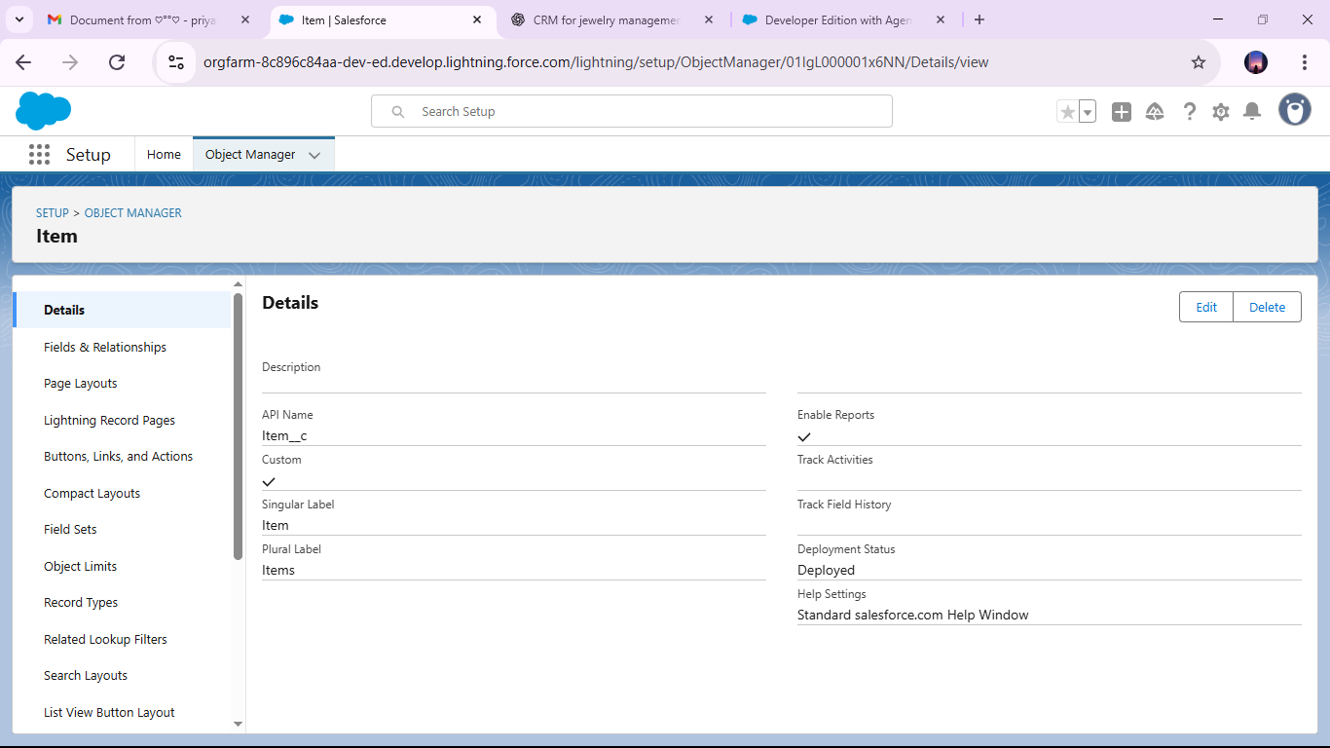

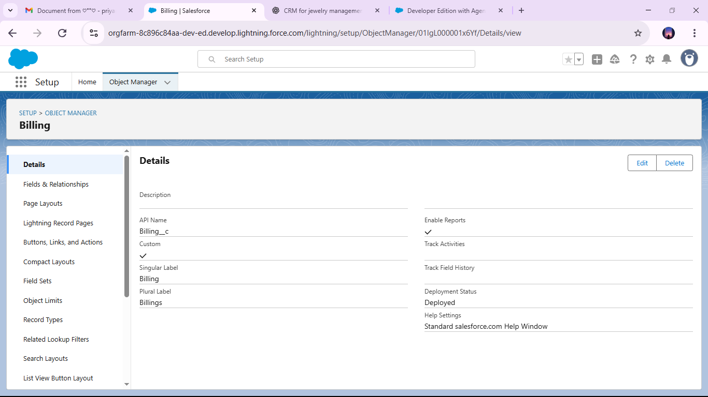

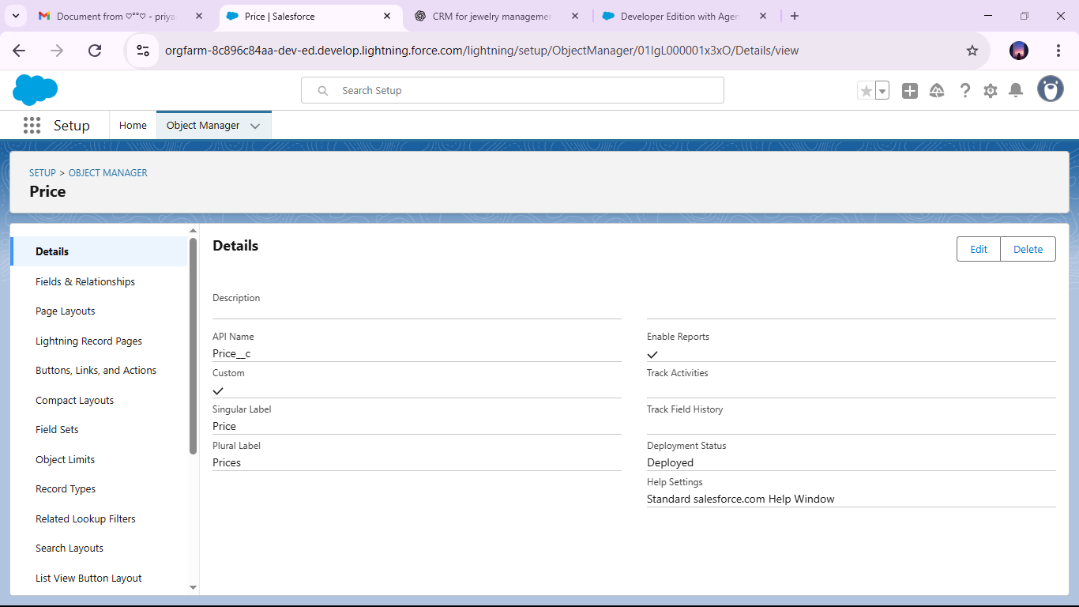

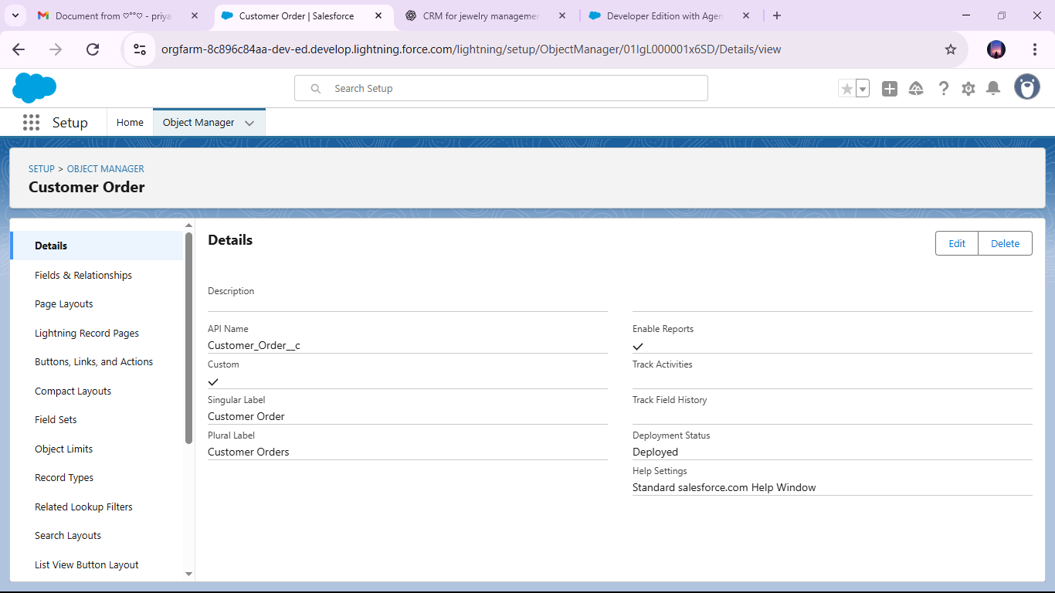

* Configured fields and relationships

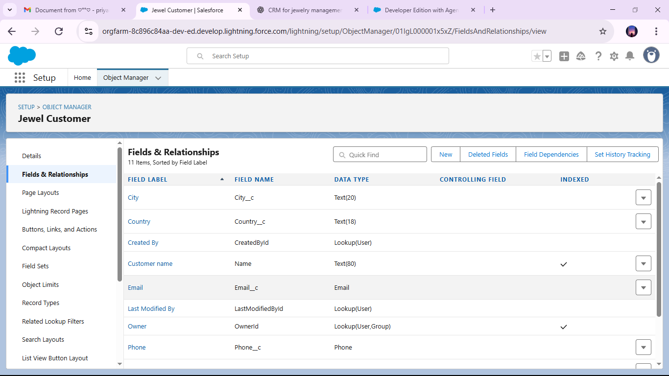

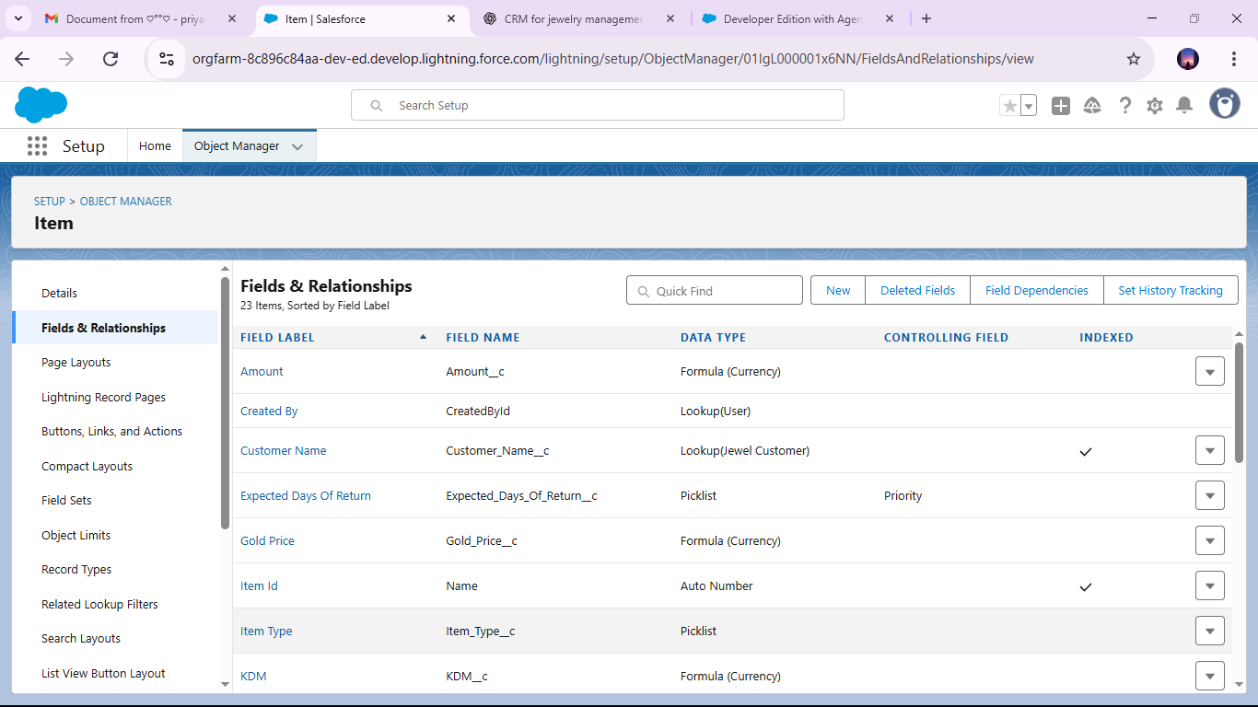

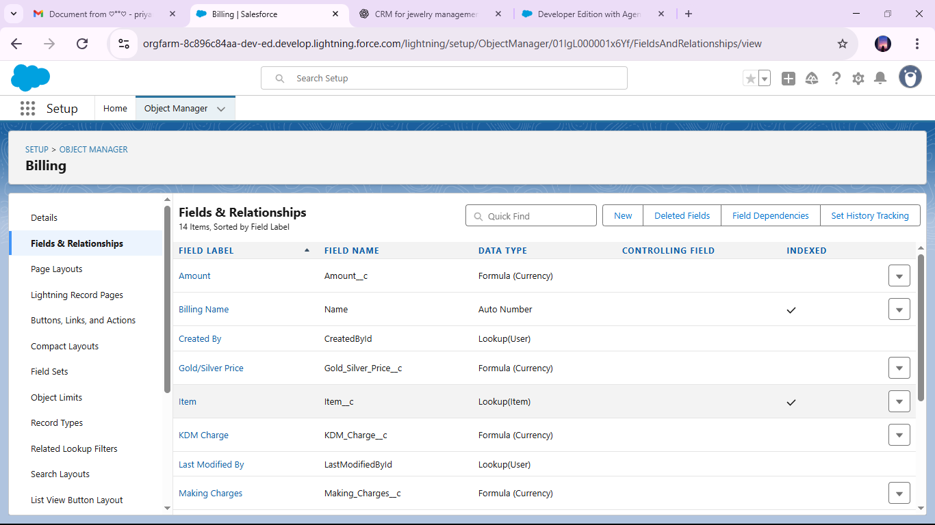

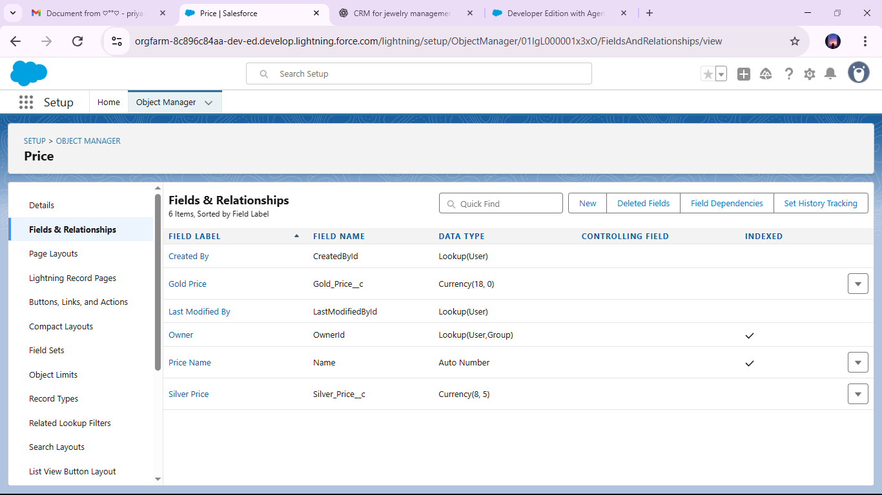

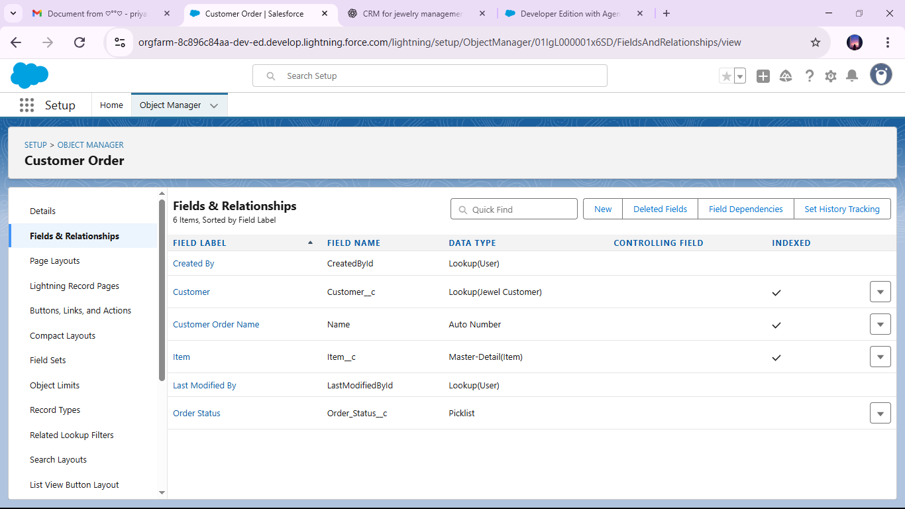

* Developed Lightning App with relevant tabs

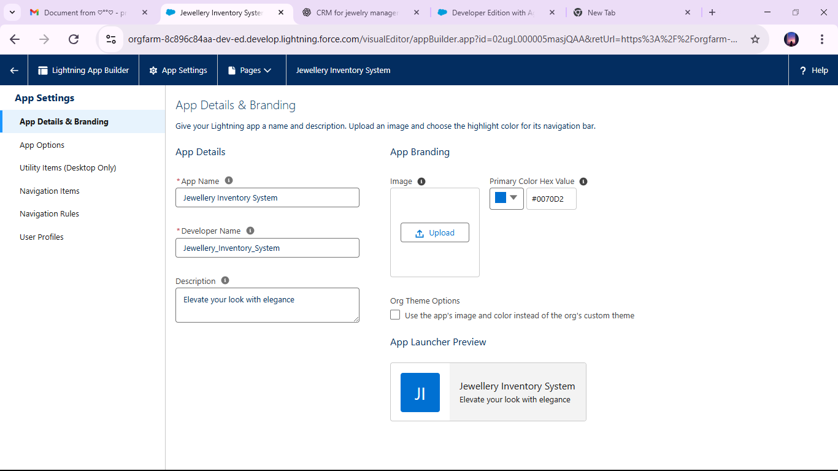

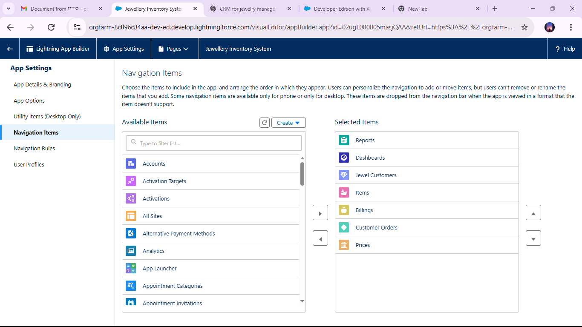

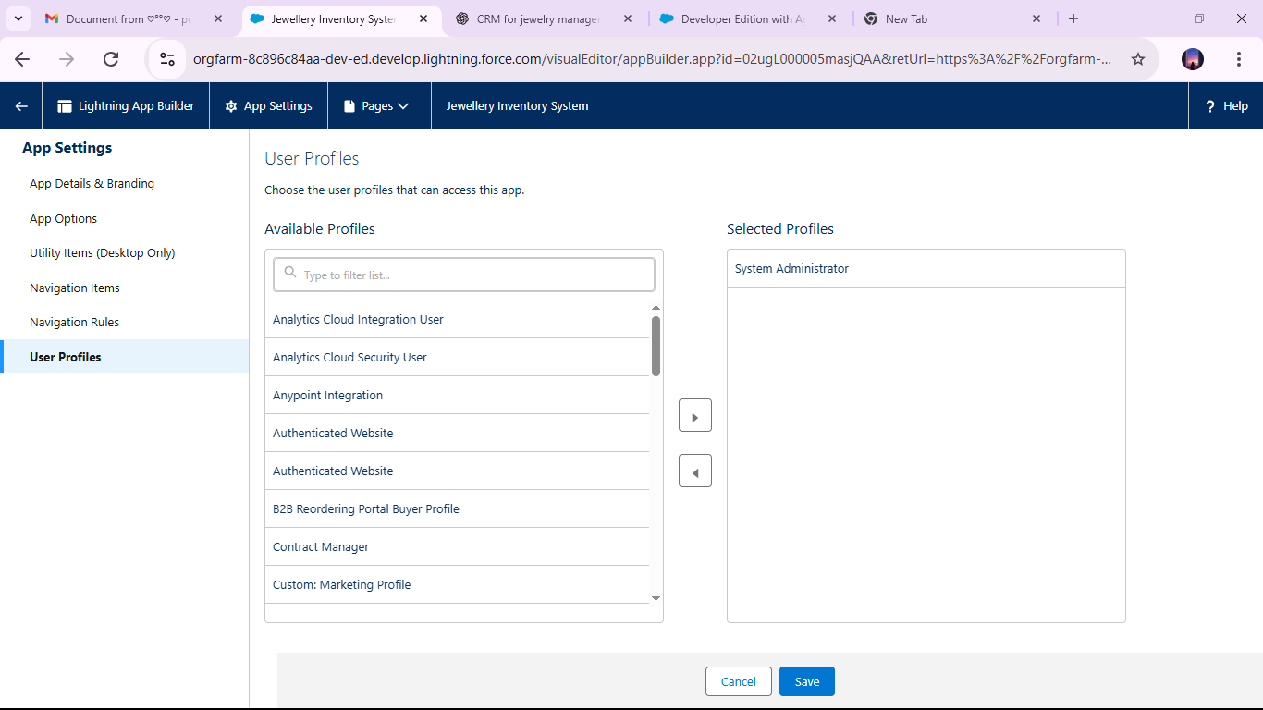

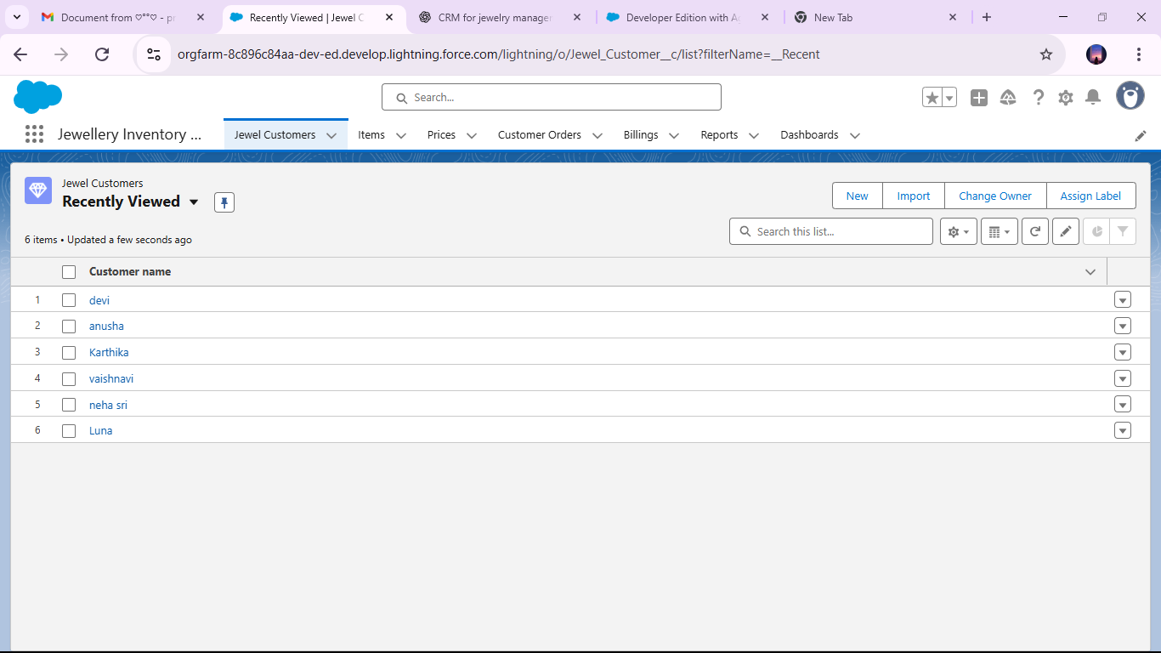

* Implemented Flows

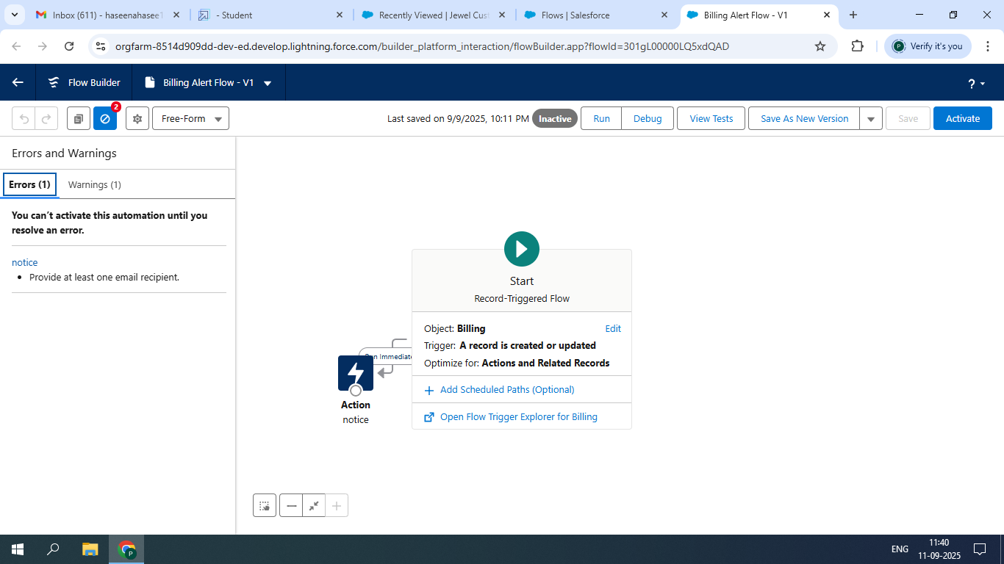

* To create a validation rule to a jewel customer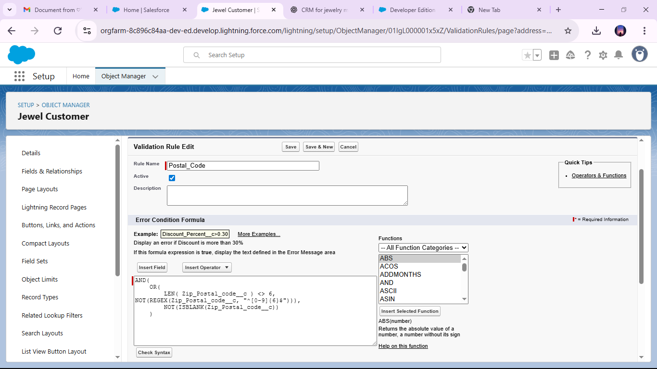 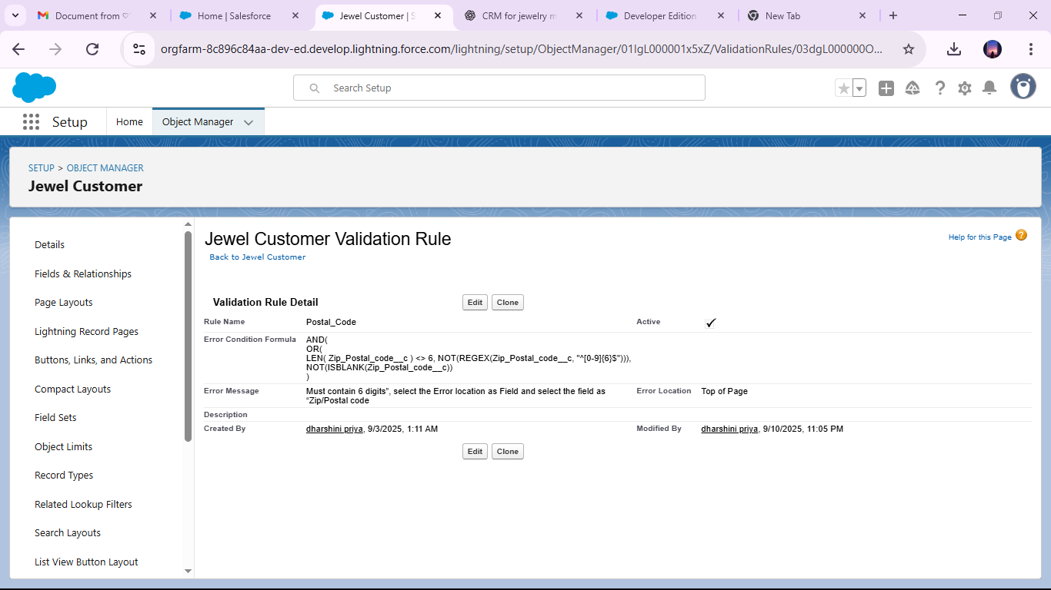
* Created profiles for Gold Smith and worker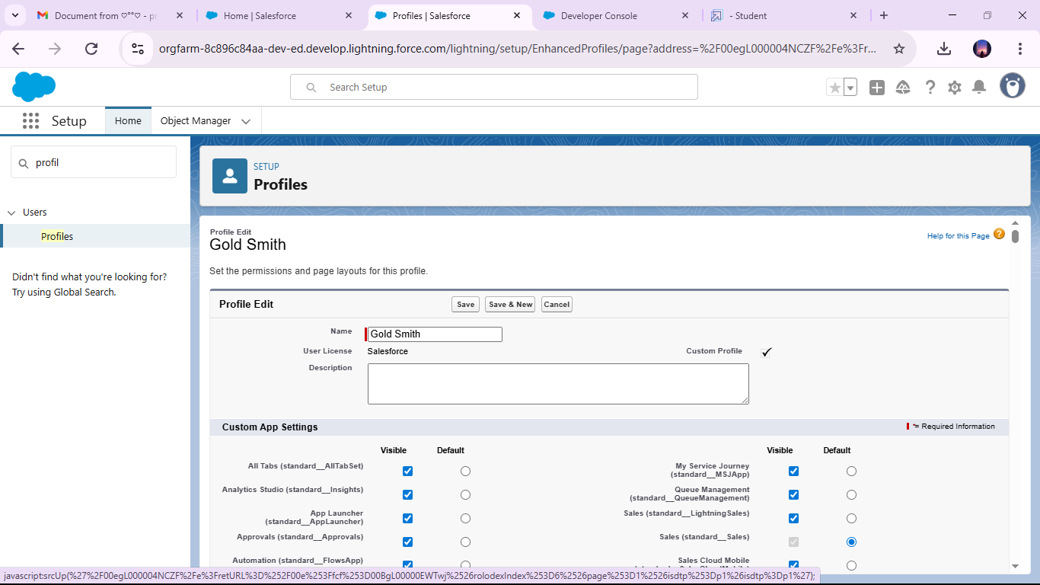

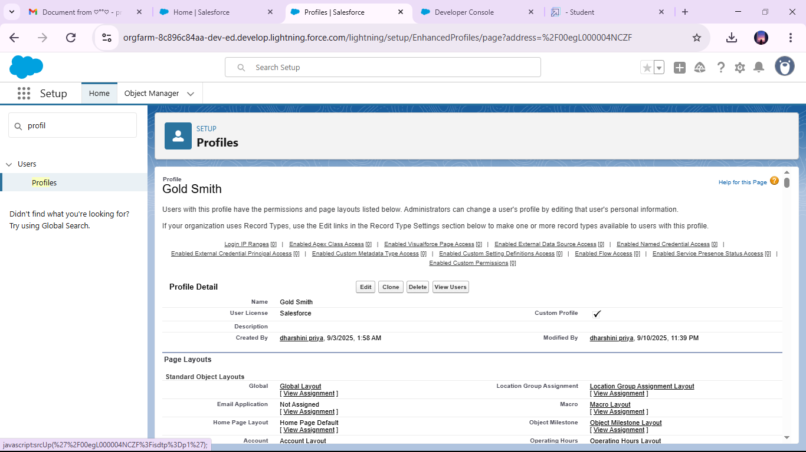

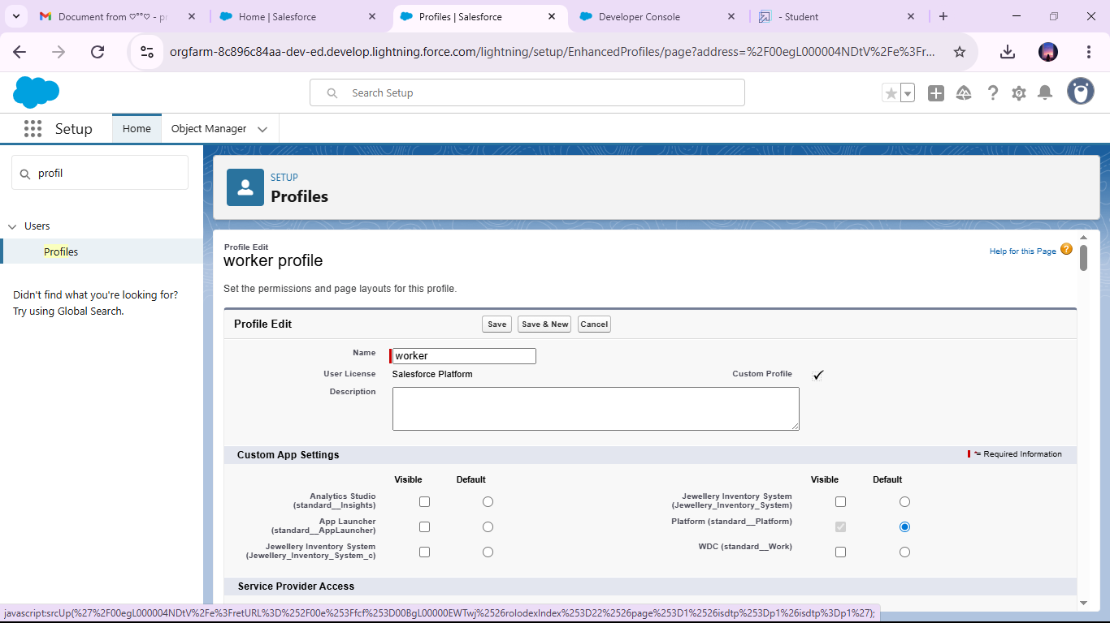

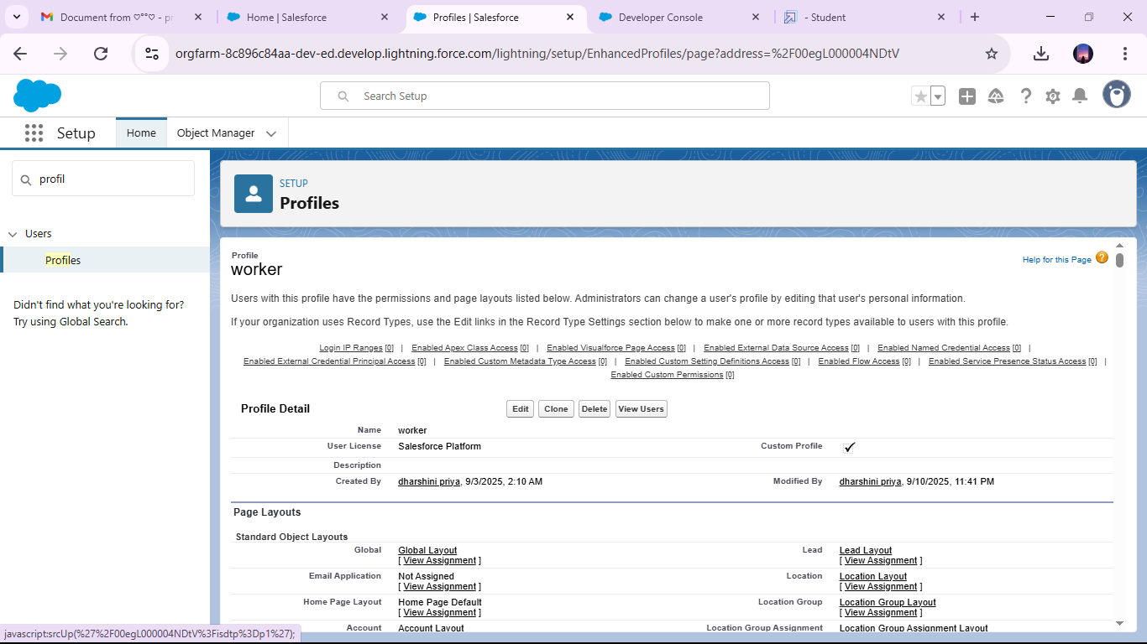

* Creating gold smith role

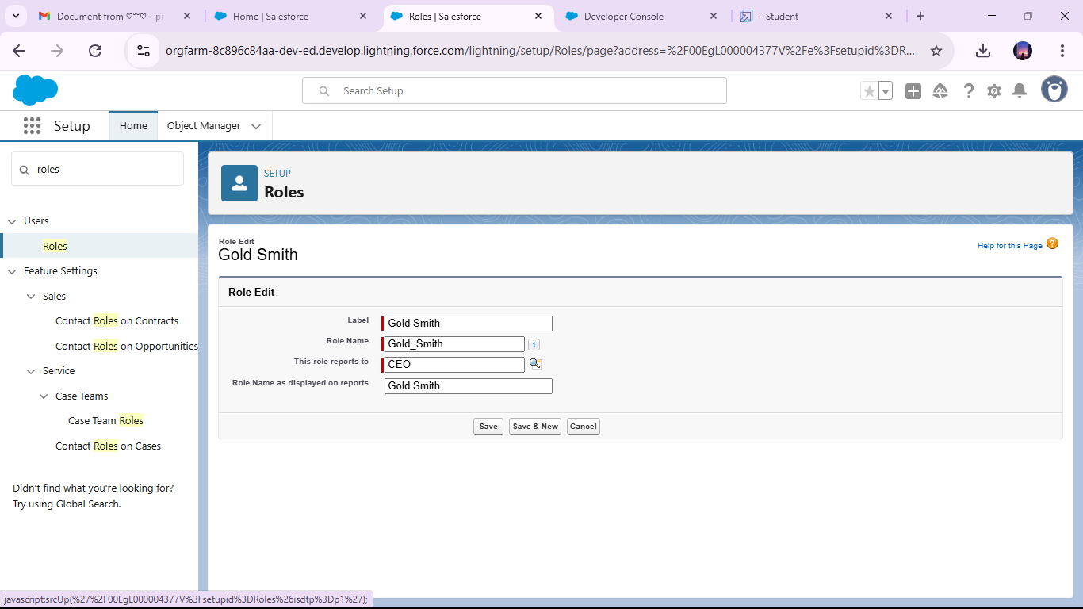

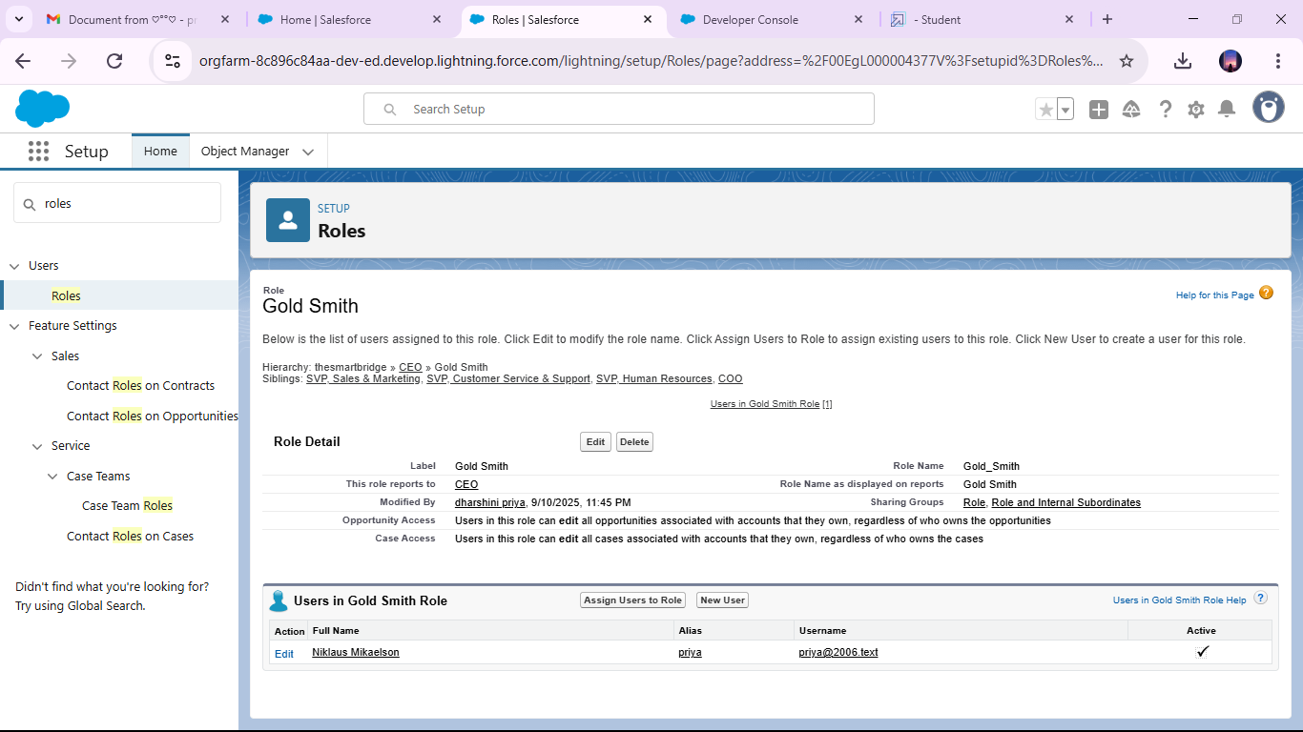

### Created one more role as Worker which reports to Gold Smith

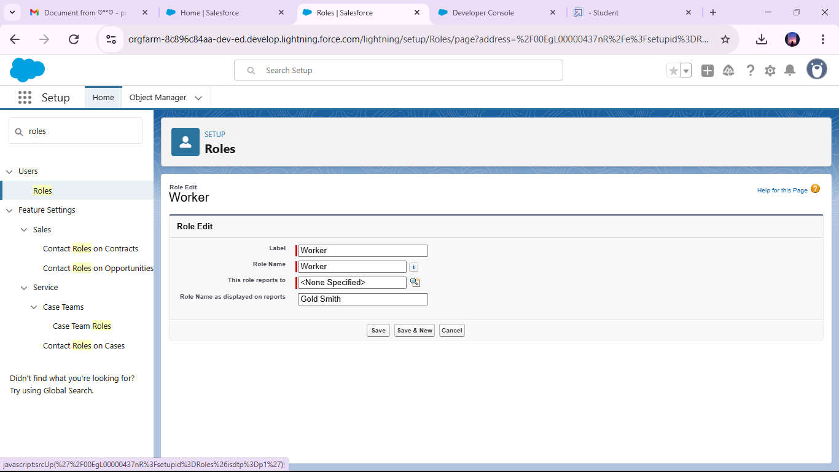

### 

### Created Users

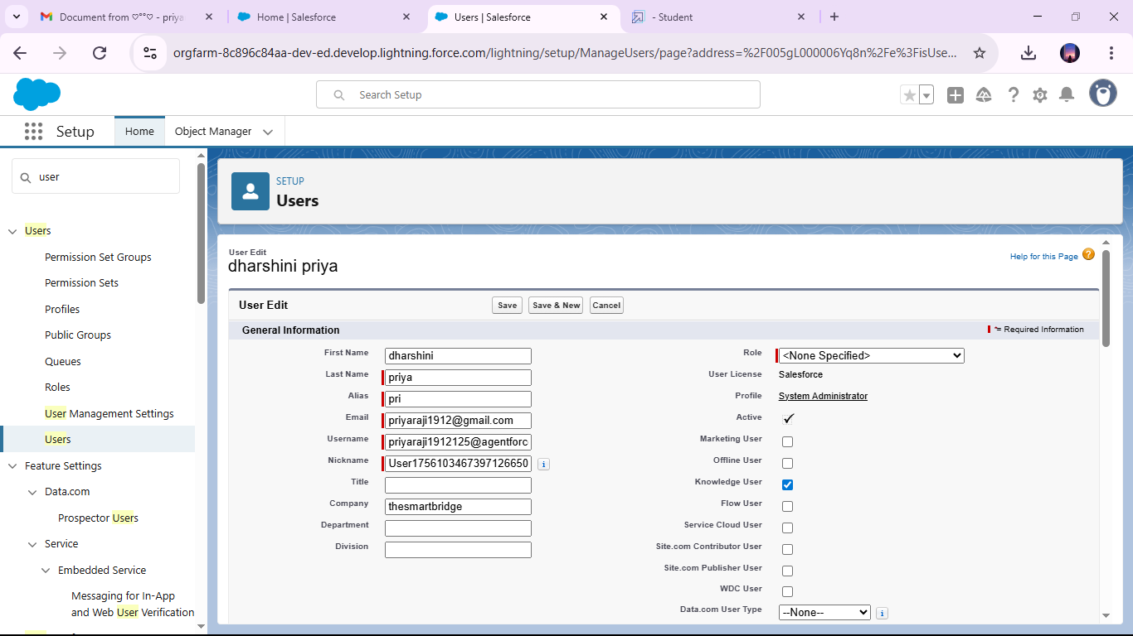 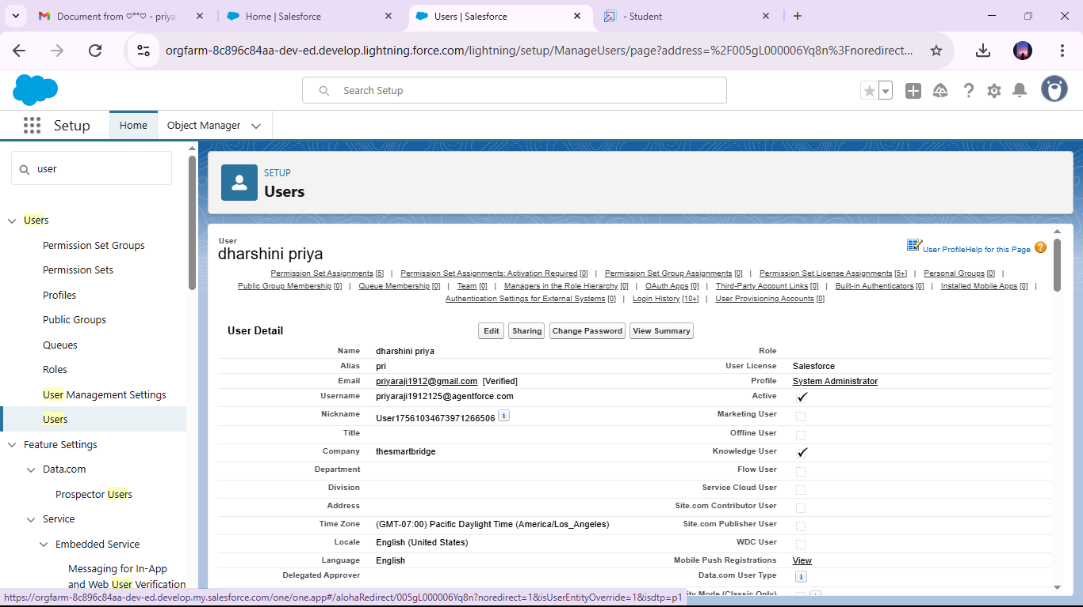 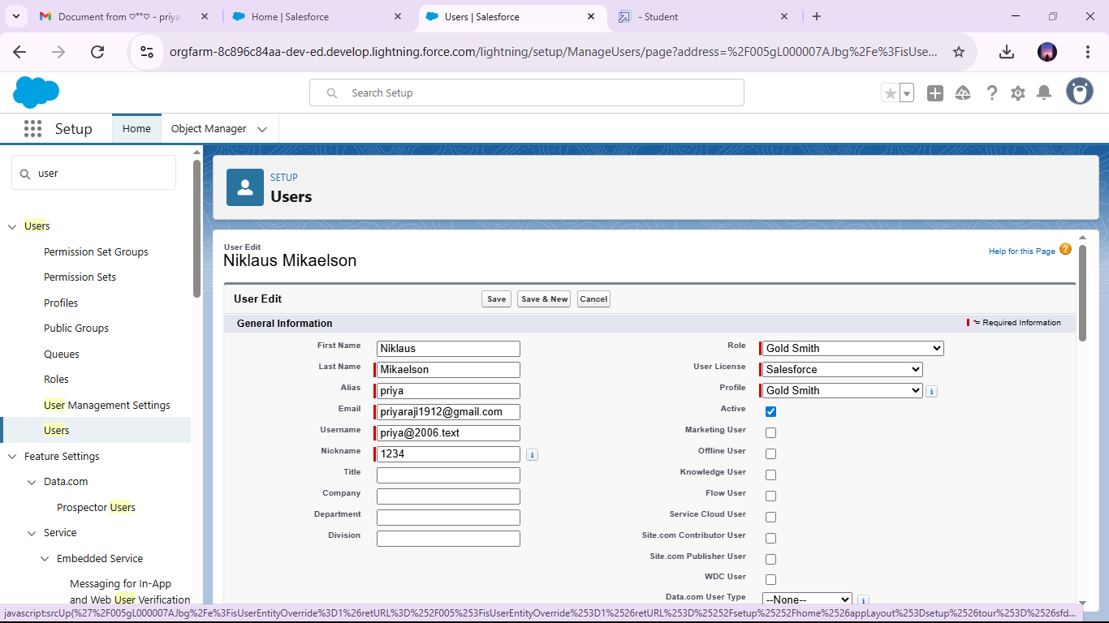 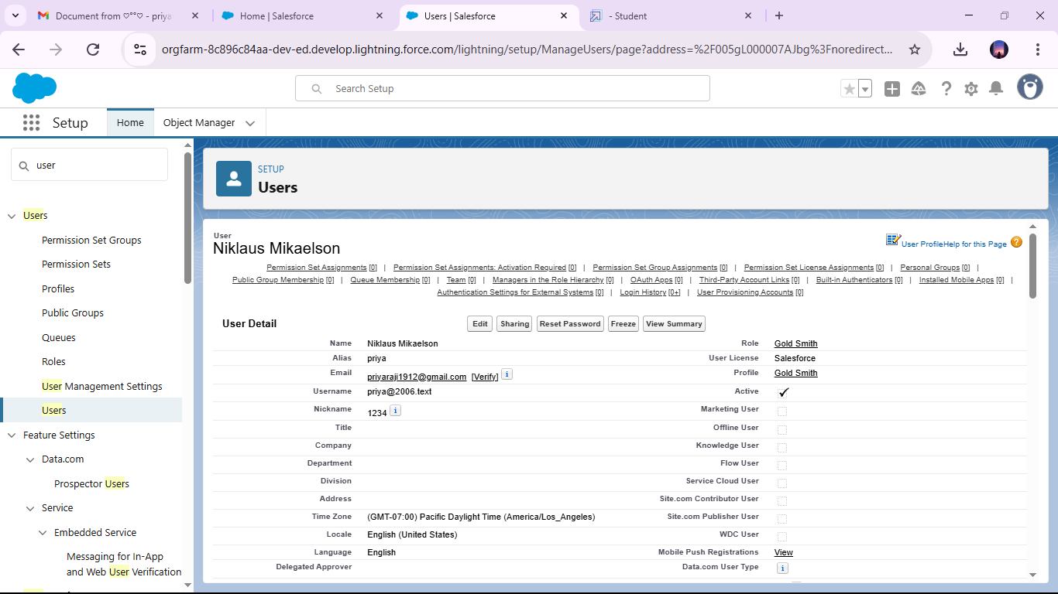 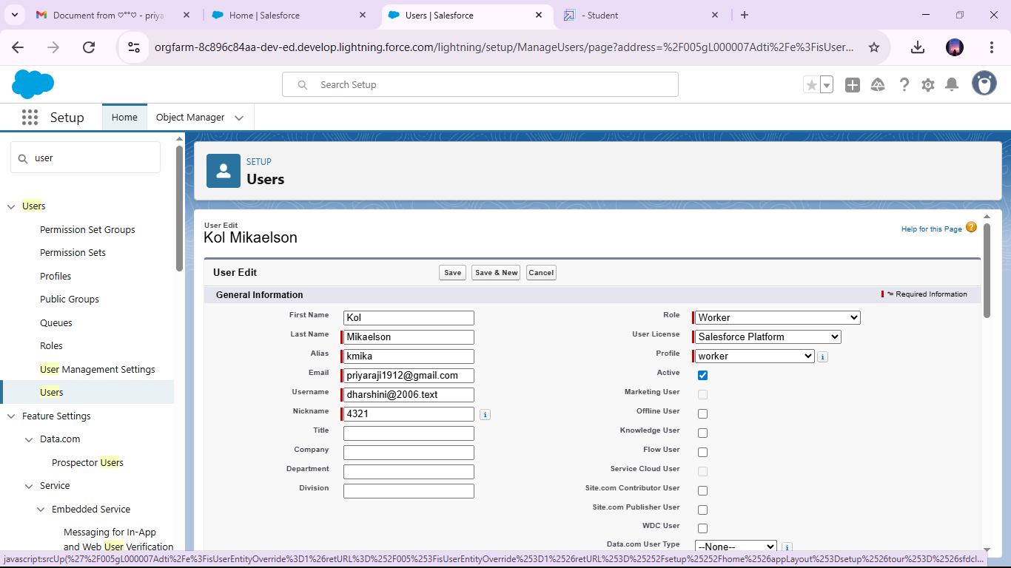

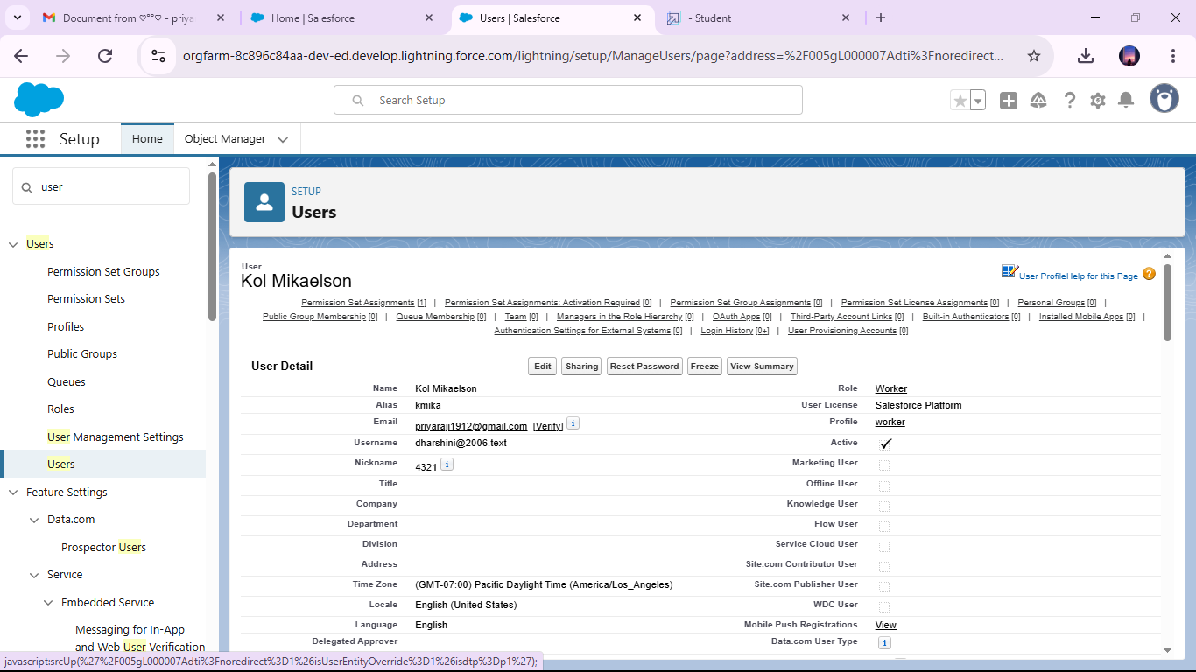 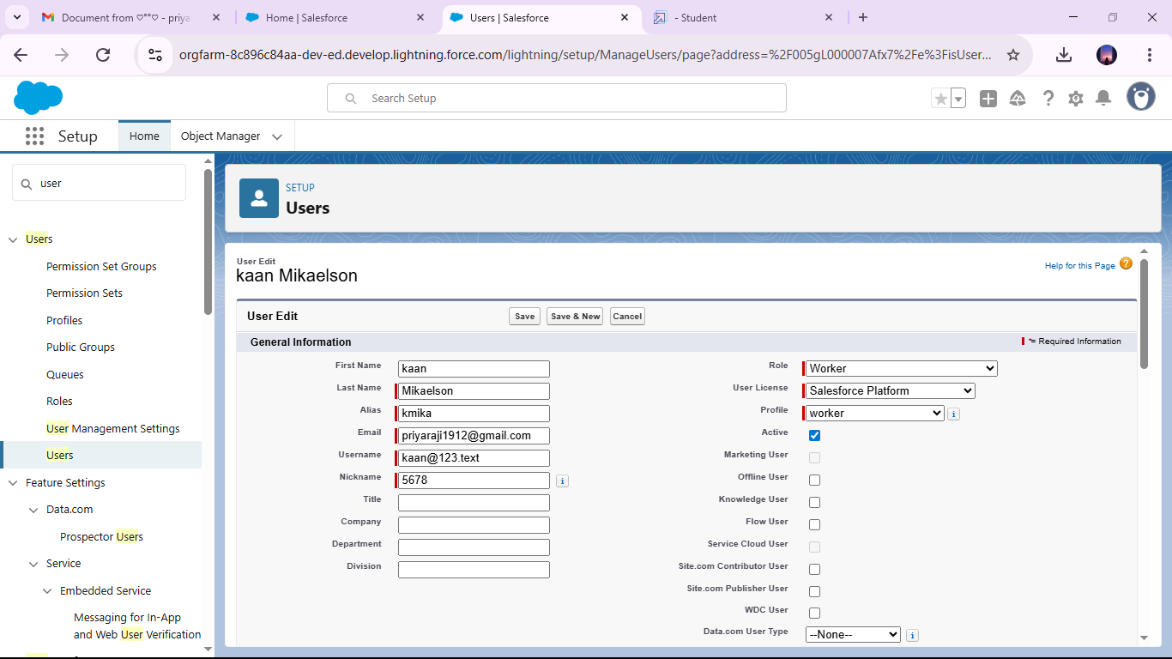 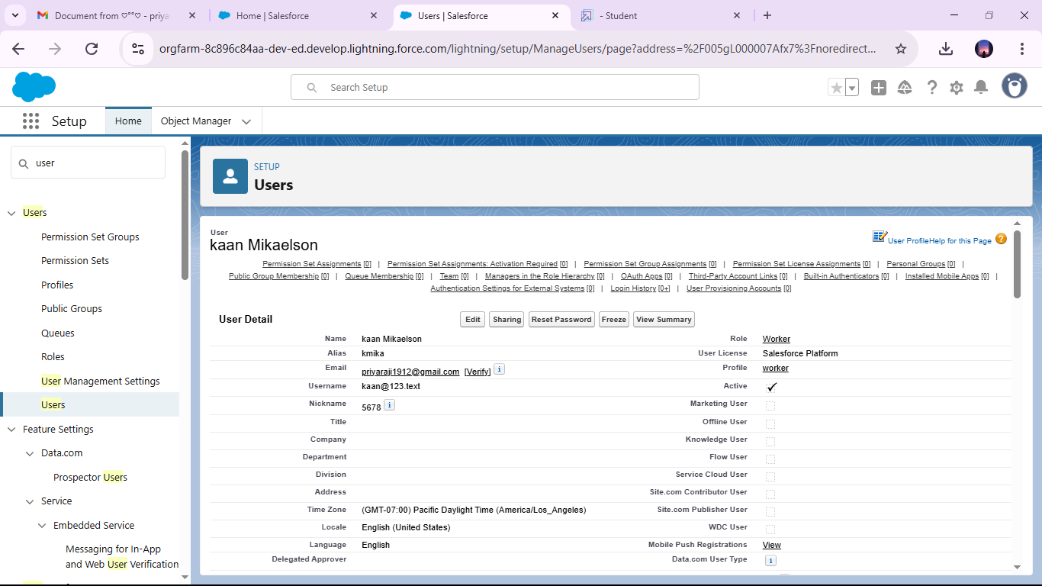

### To create a gold page layout

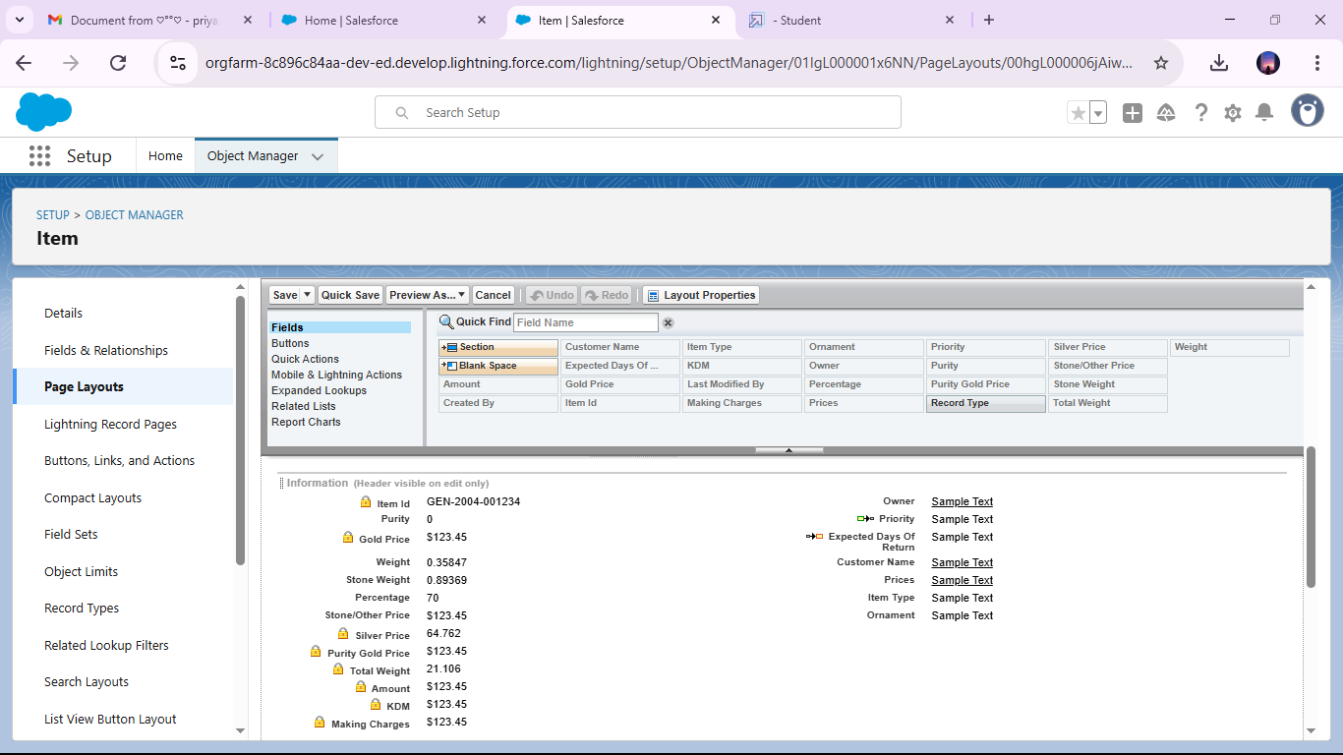

### To create a silver page layout

### 

### Created a record type for gold and silver

### image (7).png

### image (8).png

### image (9).png

### image (10).png

### Creating permission set

### image (11).png

### image (12).png

### Created a trigger handler class

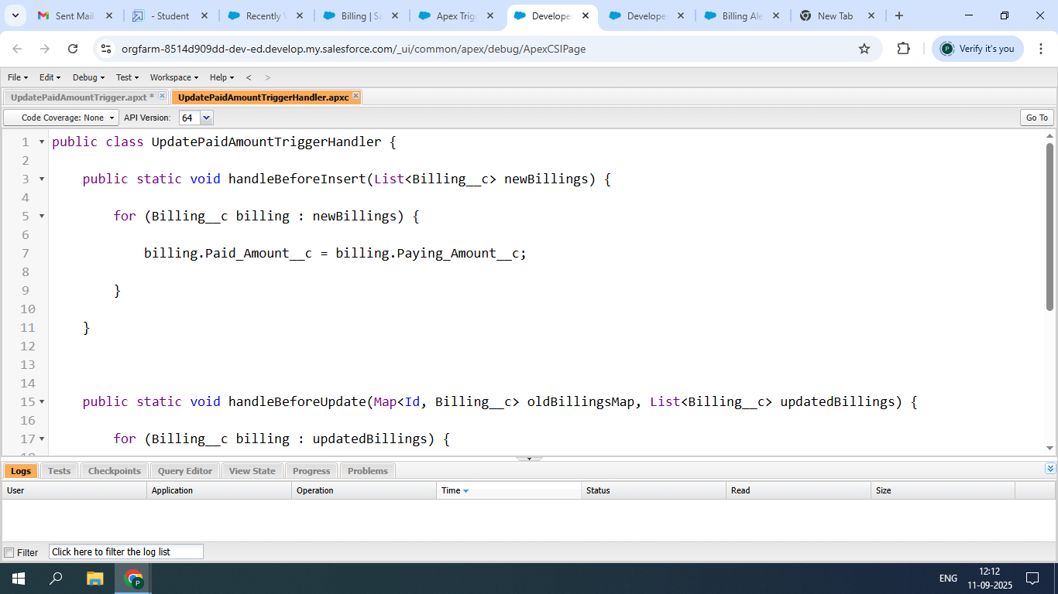

* Created the trigger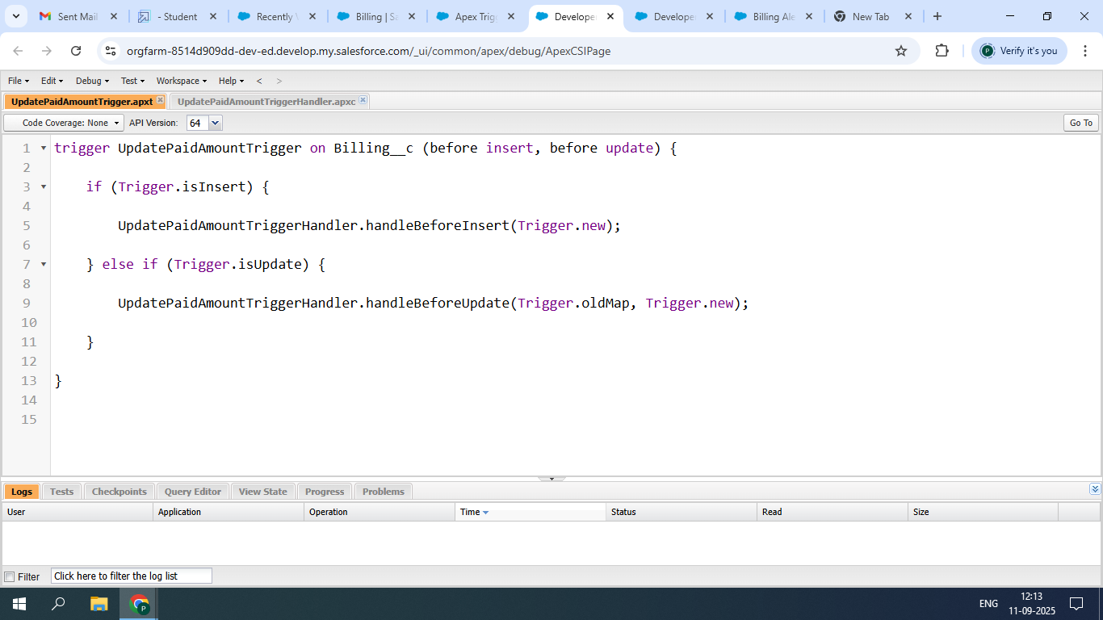

### Created a record (Jewel Customer)

### 

### 

### 

### 

### 

### Viewing a record (Jewel Customer)

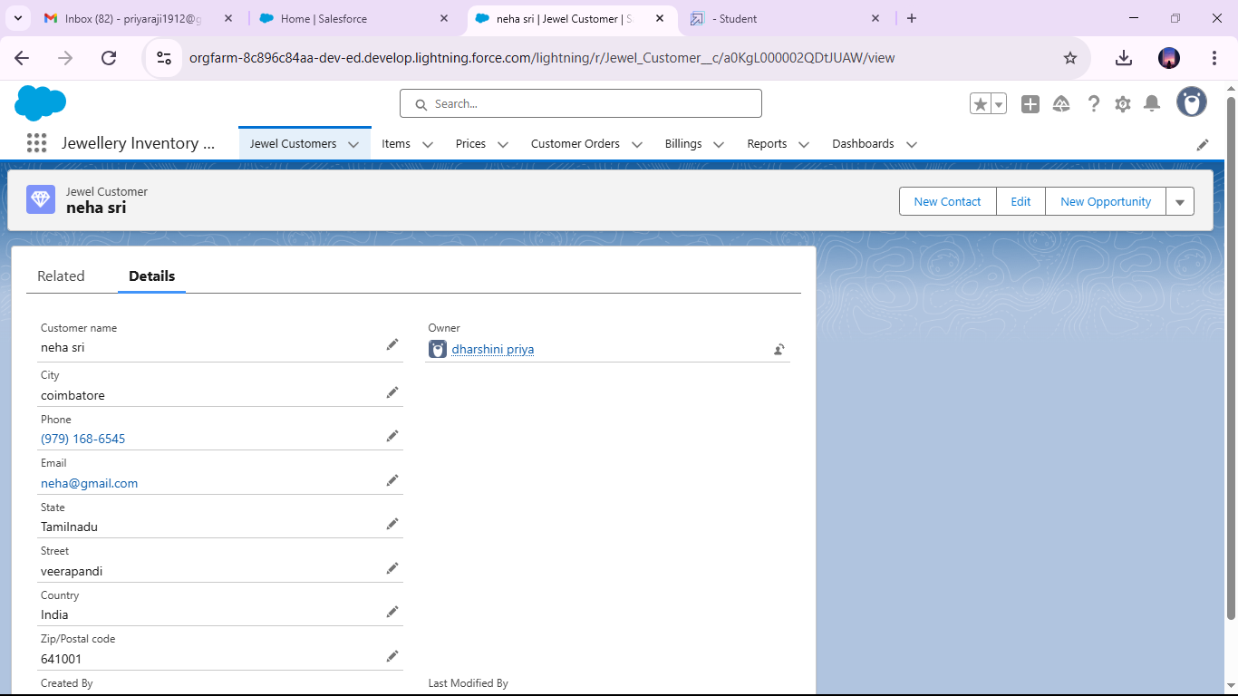

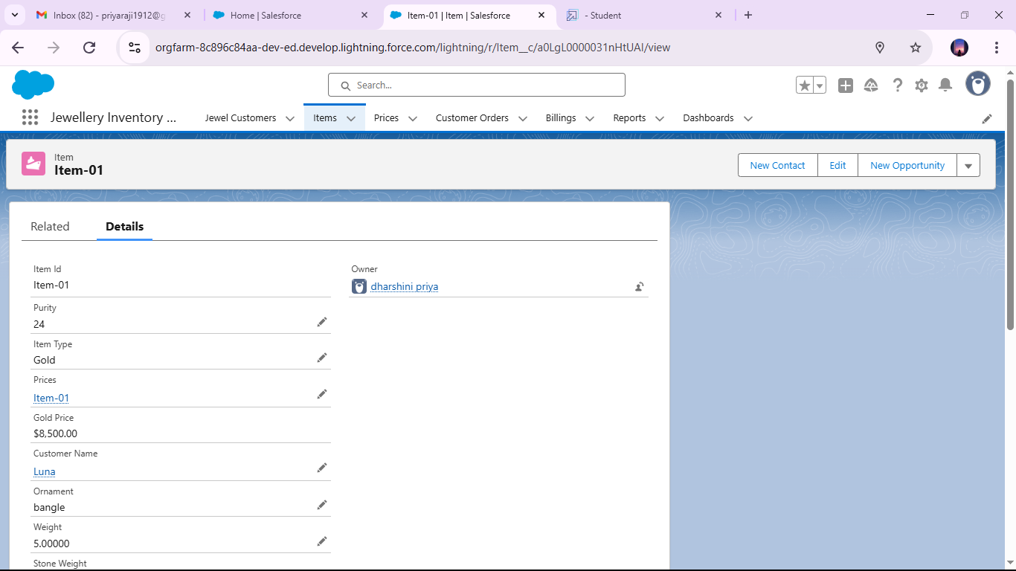 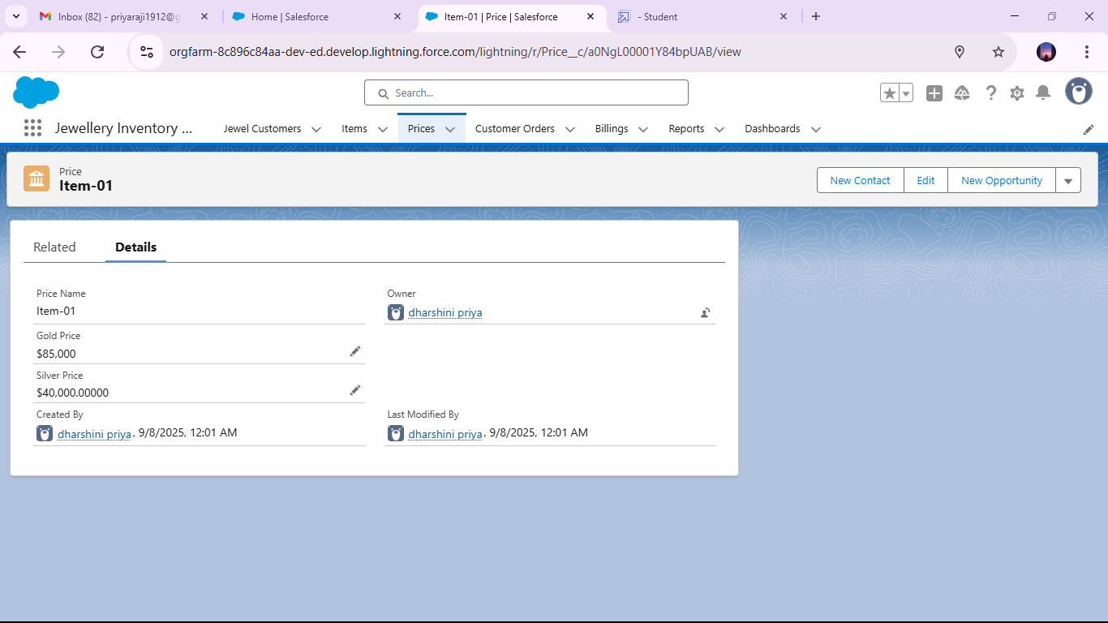 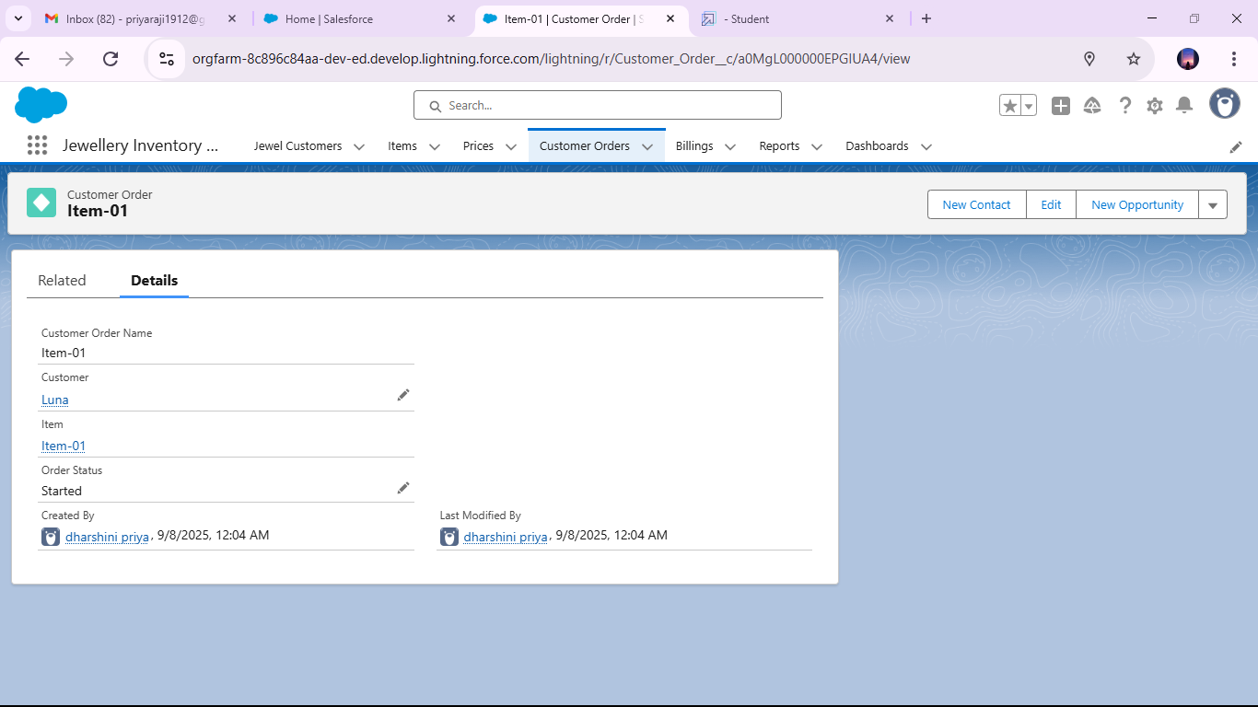

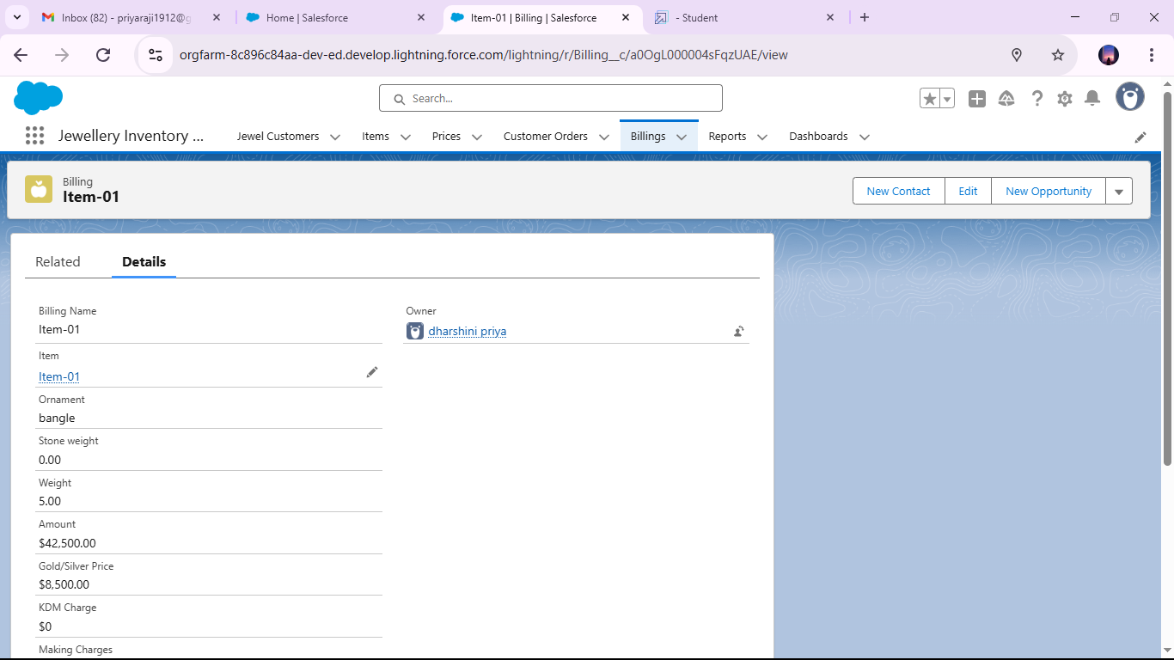

### Created report

### 

### Created dashboard

### 

### 

CONCLUSION

The Jewelry CRM successfully integrates Jewel Customer, Customer Order, Items,Price, and Billing objects into one streamlined system. With validation rules ensuring data accuracy and record-triggered flows with actions and email alerts providing automation, the system improves efficiency and customer satisfaction.